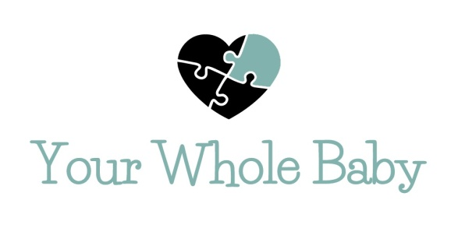
News Release

FOR IMMEDIATE RELEASE: Month Day, 2015 (Example: April 5, 2015)
Contact:
Your Name, Representative for Your Whole Baby
Your Whole Baby
www.YourWholeBaby.org
Email: Your Email Address
Phone: Your Phone Number

LOCAL INTACTIVISTS DEMONSTRATE AT ABC HOSPITAL TO RAISE AWARENESS ON THE HORRORS OF MALE CIRCUMCISION
Male Circumcision is Just as Horrifying as the Most Common Type of Female Circumcision and Yet FGM Became Illegal in the USA in 1997 and MGM is Performed Thousands of Times Per Day in Trusted Medical Facilities

City, State – On Wednesday, April 6, 2015 at 1PM, local intactivists, dressed as deranged nurses or armed with a real circumstraint or including four year old protester, Susie or whatever makes your protest unique, will be demonstrating outside of ABC Hospital to raise awareness on the horrors of circumcision.

As you read these words, newborn baby boys across the country are screaming in agony as part of their penises are ripped and cut from their body. Circumcision is a cruel and completely unnecessary welcome to the world. It is extremely, extremely painful and there is no pain management that can be given to a newborn to alleviate 100% of the pain. According to Stanford’s School of Medicine, complications range from hemorrhaging to death. Many other complications, such as painful erections from too much skin being removed, do not show up until boys reach puberty. The pediatric organizations of Canada, Australia and New Zealand do not recommend routine infant circumcision because it is not medically necessary. Many American doctors are beginning to speak out against circumcision, but it is a lucrative business, which is slowing the progress to end this barbaric practice. The likes of Ben Affleck, Mario Lopez, Craig Ferguson, Cameron Diaz and Alicia Silverstone have spoken out against circumcision.

Your Whole Baby wants all expecting parents to know that circumcision is unnecessary, painful and damaging for the baby it happens to and for the man he becomes. Your Whole Baby is dedicated to the cause of helping end routine infant circumcision. America’s babies deserve better.

For more information, visit www.yourwholebaby.org or contact Your Name at Your Email Address/Your Phone Number.
###

